**Project IMPLEMENTATION**

**7.0 GETTING STARTED**

## 7.1 Logging On

After the customary briefing about the on line examination by the programme coordinator, trainees are asked to move to the examination room. In the examination room, on every computer desk top an icon with the name of ON LINE EXAMINATION is displayed as shown in fig (7.0.0). A participant has just to click the shown icon to start the examination proceedings. After clicking the said icon the main screen of the examination will pop up as shown in fig (7.0.1)

 Fig (8.0.0)

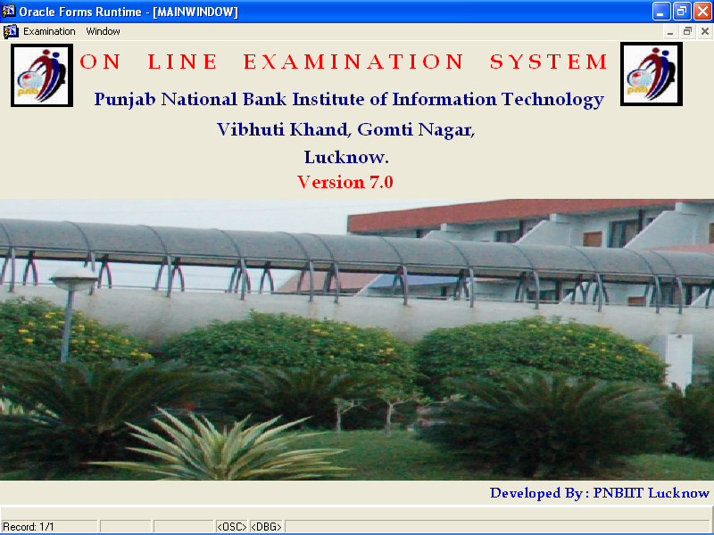

Fig (7.0.1)

## 7.2 System Menu

### On clicking examination menu tool bar it gets expanded to sub menu items as

### Shown in the fig (7.0.2)

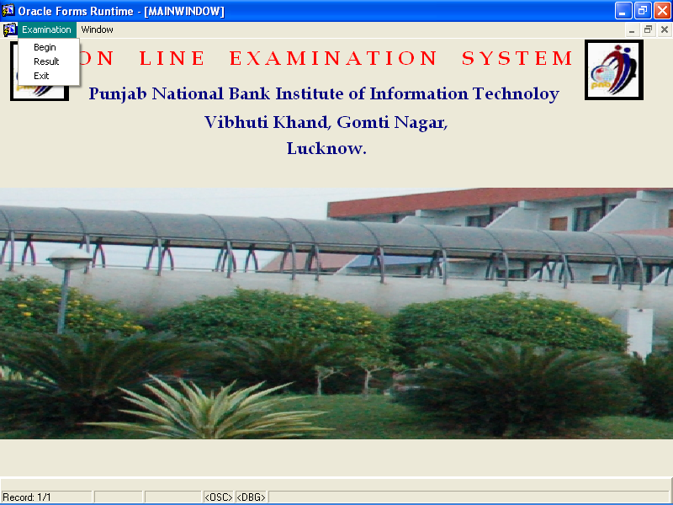

**Fig 7.0.2**

On selecting begin examination button the main examination screen will be displayed as shown in fig (7.0.3) and participants will be required to select their pre allotted roll numbers. Roll number along with their name is shown to ease their choice of selection in case they forgot their pre-assigned roll numbers. 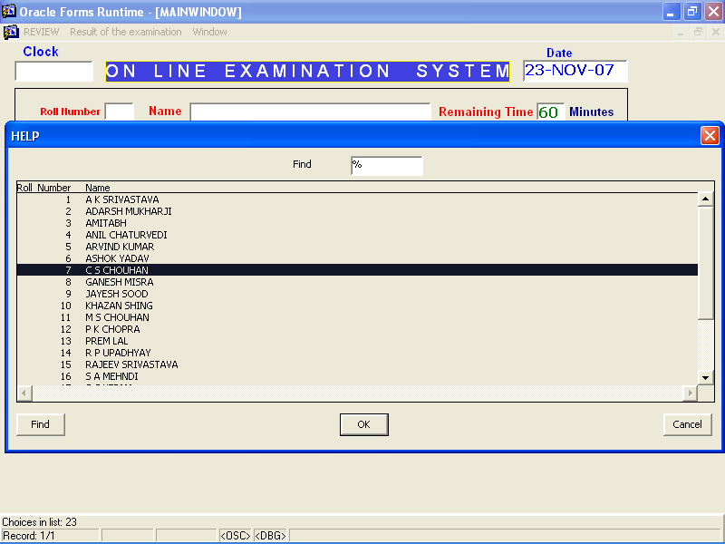

**Fig (7.0.3)**

A validation check is imposed if a trainee does not select his or her roll number. An alert message will pop up automatically on screen advising the candidate roll number can not be blank. This is mandatory item. As shown in fig (7.0.4)

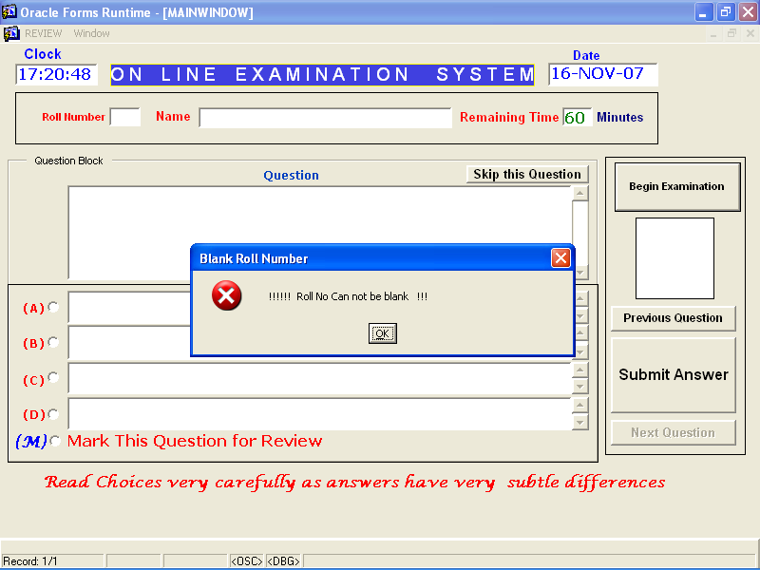

**Fig 7.0.4**

After selecting right roll number and name as shown in fig (7.0.5). a candidate has just to click begin examination button. As soon as the said button is pressed questions along with relevant choices will pop up as shown in fig (7.0.5).

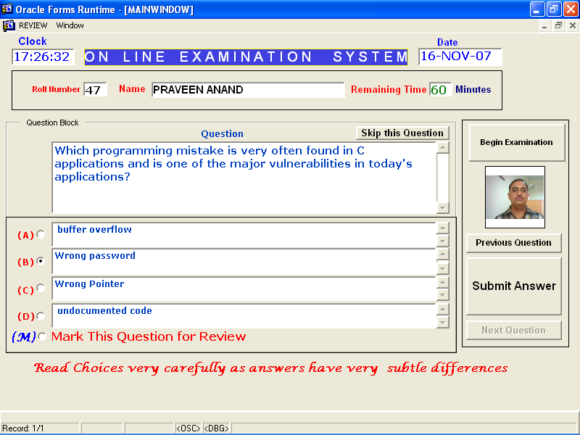

**Fig 7.0.5**

The participant is now expected to choose the right answer by clicking the radio button on left pan of the screen for example in the fig(7.0.5) a participant has selected choice (B). After selecting the desired choice a participant has to press Submit Answer button. This is essential for evaluating the answer. Participant has two other available choices for instance a) He or she may want to skip the question or b) He or she may want to mark this question for future review. For a) a participant has to press skip this question button at the top right pan of the question block. The moment one presses skip question button next question will automatically be populated in the screen. and for b) he has to choose Mark This Question for review radio button and press submit button. Next question will automatically follow.

The other two buttons namely Previous Question and Next Question are meant for navigating purpose. For example if one wants to go back to previous question for revising the choice, one may choose/click Previous Question button. After having revised the choice and if one wants to go further, one may choose Next Question Button accordingly.

In the main exam screen you will see digital clock, date and remaining time at the top. Remaining time will inform you how many minutes are left for the exam. When last five minutes are left for the exam you will have an alert message on the screen informing only five minutes are left as shown in fig (8.0.5)

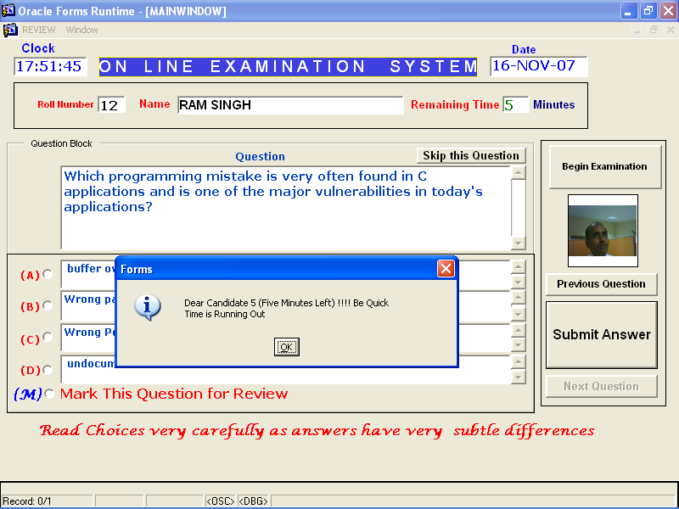

**Fig 7.0.5**

Let us assume that you have completed all the questions and want to review marked questions now. All you have to do is select review menu item which will further be expanded to review marked question sub menu item. Just select this item by clicking from the menu tool bar as shown in fig (7.0.6).

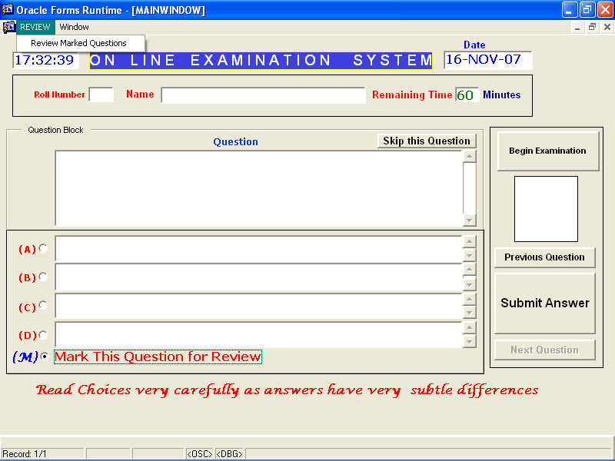

**Fig 7.0.6**

Having selected the item you will see next screen for reviewing the marked questions as displayed in fig (7.0.6).

All you have to do at this point is just to click on Review Now button. As soon as you press the start button all the marked question(s) by you will be displayed one by one. Answering procedure for review question is same as answering other unmarked questions (Screen itself is self explanatory in this regard) as shown in fig (7.0.7)

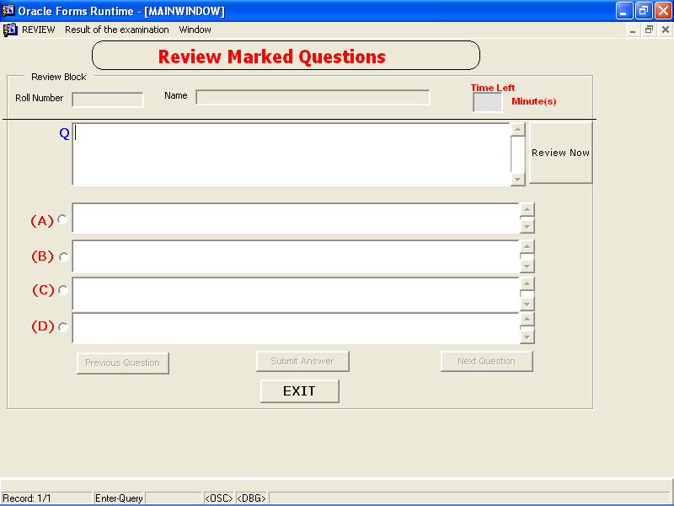

**Fig 7.0.7**

**7.3 Result of the Examination**

Now that you have had a complete examination, its time to see your score i.e how you fared in the examination. Facility is provided in software that a candidate can view his or her score immediately on completion of the examination. Many validation checks are enforced to insulate result section so that one can not manipulate marks and answers etc. Candidate desirous of viewing his or her result needs to choose result menu item from the menu tool bar as shown in fig (7.0.8).

Having selected the result menu item following screen will be displayed. User has just to click the button Click to see result button. Result of the candidate will be shown as fig (7.0.9). However while choosing the result menu option the candidate is alerted by a message saying are you sure to view the result as once you see the result you will not be allowed to login in the system again.

This message is meant to avoid inadvertent selection of the result menu in between examination. The moment one presses the button his roll number, name and photograph will be filled in the Result Ticket along with marks and percentage in non updatable mode.

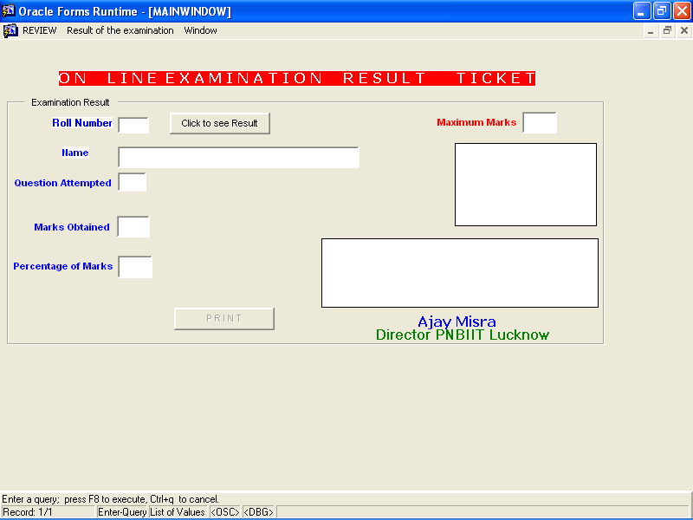

**Fig (7.0.8)**

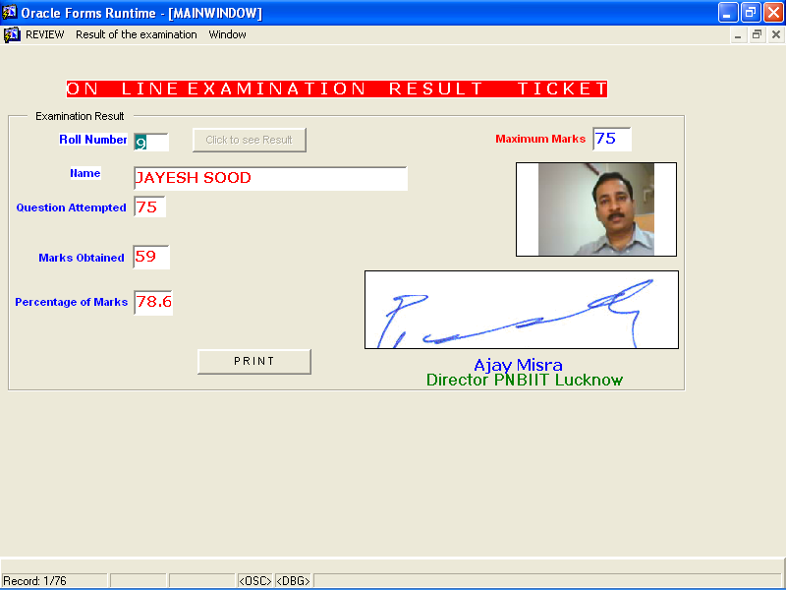

**Fig 7.0.9**

After having seen the result the candidate has only one choice i.e. exit from the examination. Once exit from the examination a candidate can not logged in second time in same day. If tried second time he or she would be declined by an alert message as shown in fig (7.0.9) “You have already logged in”

